**Blood Banking System**

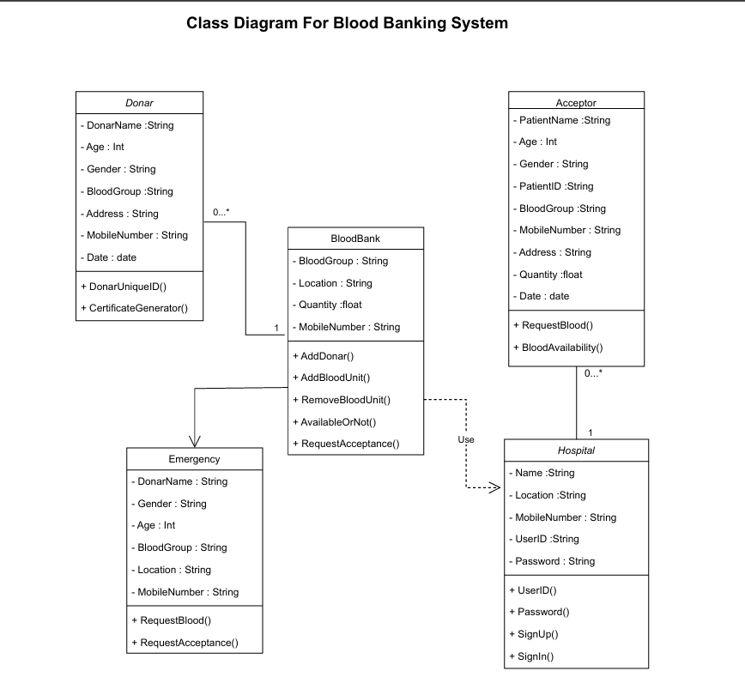

SQL Code

# Creating DataBase

Create DATABASE Blood_Banking_System;

#we have many databases among them we have to select or to mention the database name to create table(understanding to the System)

use Blood_Banking_System;

# Creating Donor table

CREATE TABLE Donor (

DonorID INT PRIMARY KEY,

DonorName VARCHAR(50) NOT NULL,

Age INT (5),

Gender VARCHAR(10),

MobileNumber VARCHAR(15) UNIQUE,

BloodGroup VARCHAR(5),

Address VARCHAR(100),

DonationDate DATE

);

#insert Data into Donor

INSERT INTO Donor (DonorName, Age, Gender, MobileNumber, BloodGroup, Address, DonationDate)

VALUES ('Divya', 22, 'Female', '9123456780', 'O-', 'Bangalore, Karnataka', '2025-09-06'),

('Sri Devi', 42, 'Female', '9876001234', 'A+', 'Chennai, Tamil Nadu', '2025-09-05'),

('Sowmya', 19, 'Female', '9988776655', 'O+', 'Guntur, Andhra Pradesh', '2025-09-06'),

('Anjaneyulu', 48, 'Male', '9123004567', 'B-', 'Mumbai, Maharashtra', '2025-09-06');

('Vijay Kumar', 22, 'Male', '9876543210', 'O+', 'Hyderabad, Telangana', '2025-09-06');

# Display Data

Select * from Donor;

#create Acceptor Table

use Blood_Banking_System;;

CREATE TABLE Acceptor (

AcceptorID INT PRIMARY KEY AUTO_INCREMENT,

AcceptorName VARCHAR(50) NOT NULL,

Age INT (5),

Gender VARCHAR(10),

MobileNumber VARCHAR(15) UNIQUE,

BloodGroup VARCHAR(5),

Address VARCHAR(100),

Quantity INT (5),

AcceptDate DATE

);

#insert Data into Acceptor

INSERT INTO Acceptor (AcceptorName, Age, Gender, MobileNumber, BloodGroup, Address, Quantity, AcceptDate)

VALUES

('Sahithi', 24, 'Female', '9012345678', 'A+', 'Hyderabad, Telangana', 2, '2025-09-06'),

('Rama', 35, 'Male', '9023456789', 'O-', 'Vijayawada, Andhra Pradesh', 1, '2025-09-06'),

('Sita', 30, 'Female', '9034567890', 'B+', 'Chennai, Tamil Nadu', 3, '2025-09-05'),

('Lakshmana', 28, 'Male', '9045678901', 'AB+', 'Bangalore, Karnataka', 2, '2025-09-04'),

('Krishna', 40, 'Male', '9056789012', 'O+', 'Delhi', 1, '2025-09-06');

# Display Data

Select * from Acceptor;

#create table for Blood bank

CREATE TABLE BloodBank (

BloodBankID INT PRIMARY KEY AUTO_INCREMENT,

BloodGroup VARCHAR(5) NOT NULL,

Location VARCHAR(100) NOT NULL,

UnitsQuantity INT (5),

MobileNumber VARCHAR(15) UNIQUE

);

#inserting Data

INSERT INTO BloodBank (BloodGroup, Location, UnitsQuantity, MobileNumber)

VALUES

('A+', 'Hyderabad', 20, '9876543210'),

('B-', 'Chennai', 15, '9123456780'),

('O+', 'Bangalore', 30, '9988776655'),

('AB+', 'Delhi', 10, '9123004567'),

('O-', 'Mumbai', 25, '9090909090');

# Display Data

Select * from BloodBank;

#create Table for Hospital

CREATE TABLE Hospital (

HospitalID INT PRIMARY KEY AUTO_INCREMENT,

HospitalName VARCHAR(100) NOT NULL,

Location VARCHAR(100) NOT NULL,

MobileNumber VARCHAR(15) UNIQUE NOT NULL,

Password VARCHAR(50) NOT NULL

);

#insert data into Hospital Table

INSERT INTO Hospital (HospitalName, Location, MobileNumber, Password)

VALUES

('Apollo Hospitals', 'Hyderabad', '9876543210', 'apollo@123'),

('Yashoda Hospitals', 'Secunderabad', '9123456780', 'yashoda@123'),

('SaiRam Hospital', 'Bangalore', '9988776655', 'fortis@123'),

('AIIMS', 'Delhi', '9123004567', 'aiims@123'),

('Care Hospitals', 'Visakhapatnam', '9090909090', 'care@123');

# Display Data

Select * from Hospital;

#create table for Emergency

CREATE TABLE Emergency (

EmergencyID INT PRIMARY KEY AUTO_INCREMENT,

DonarName VARCHAR(100) NOT NULL,

DonarID INT NOT NULL,

Gender VARCHAR(10),

Age INT (5),

BloodGroup VARCHAR(5) NOT NULL,

Location VARCHAR(100) NOT NULL,

MobileNumber VARCHAR(15),

RecentDonatedDate DATE NOT NULL

);

#insert data into Emergency

INSERT INTO Emergency (DonarName, DonarID, Gender, Age, BloodGroup, Location, MobileNumber, RecentDonatedDate)

VALUES

('Divya', 1, 'Female', 26, 'O-', 'Hyderabad', '9876543210', '2025-09-06'),

('Sri Devi', 2, 'Female', 30, 'A+', 'Chennai', '9123456780', '2025-09-06'),

('Sowmya', 3, 'Female', 24, 'O+', 'Bangalore', '9988776655', '2025-09-06'),

('Anjaneyulu', 4, 'Male', 35, 'B-', 'Delhi', '9123004567', '2025-09-06'),

('Vijay Kumar', 5, 'Male', 32, 'O+', 'Mumbai', '9090909090', '2025-09-06');

# Display Data

Select * from Emergency;

Joins

#innerJoin

use Blood_Banking_System;

SELECT d.DonorName, d.BloodGroup, e.Location, e.RecentDonatedDate

FROM Donor d

INNER JOIN Emergency e ON d.DonorID = e.DonarID;

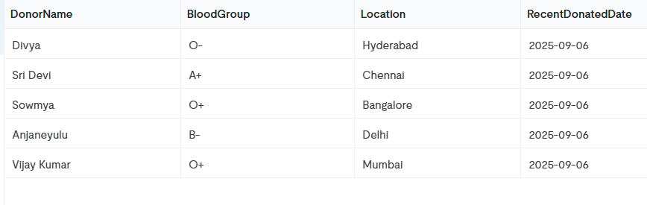

#LeftJoin

SELECT d.DonorName, d.BloodGroup, a.AcceptorName, a.UnitsQuantity

FROM Donor d

LEFT JOIN Acceptor a ON d.BloodGroup = a.BloodGroup;

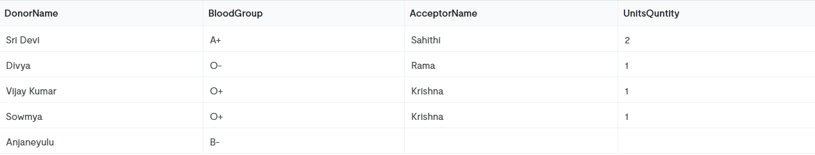

#RightJoin

SELECT h.HospitalName, h.Location, a.AcceptorName, a.BloodGroup

FROM Donor d

RIGHT JOIN Hospital h ON h.Location LIKE '%Hyderabad%'

RIGHT JOIN Acceptor a ON a.Address LIKE '%Hyderabad%';

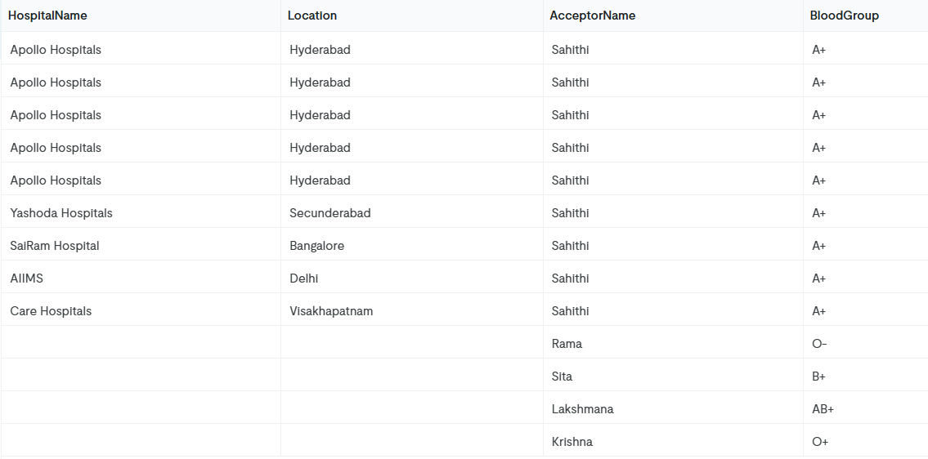

#FullOuterJoin

use Blood_Banking_System;

SELECT d.DonorName, d.BloodGroup, a.AcceptorName, a.BloodGroup

FROM Donor d

LEFT JOIN Acceptor a ON d.BloodGroup = a.BloodGroup

UNION

SELECT d.DonorName, d.BloodGroup, a.AcceptorName, a.BloodGroup

FROM Donor d

RIGHT JOIN Acceptor a ON d.BloodGroup = a.BloodGroup;

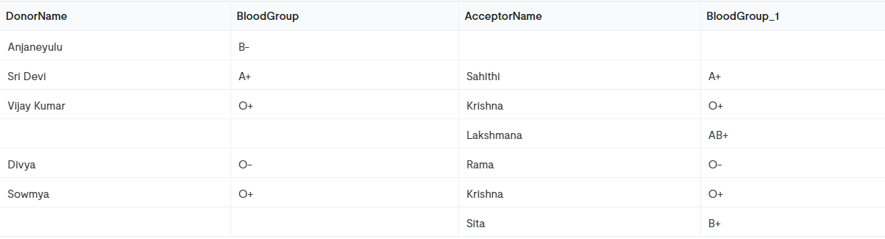

#CrossJoin

use Blood_Banking_System;

SELECT h.HospitalName, b.BloodGroup, b.UnitsQuantity

FROM Hospital h

CROSS JOIN BloodBank b;

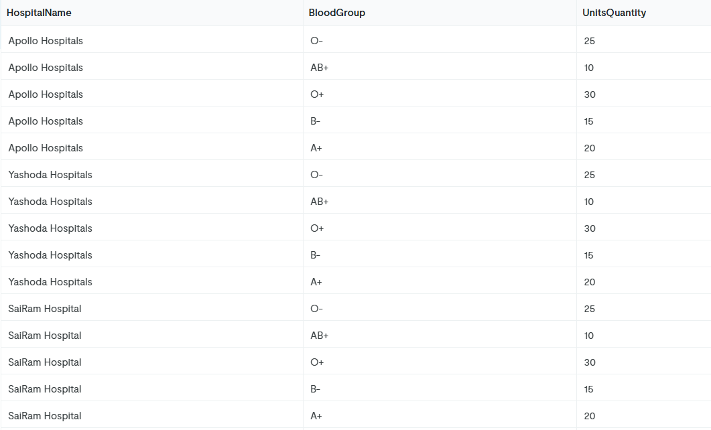

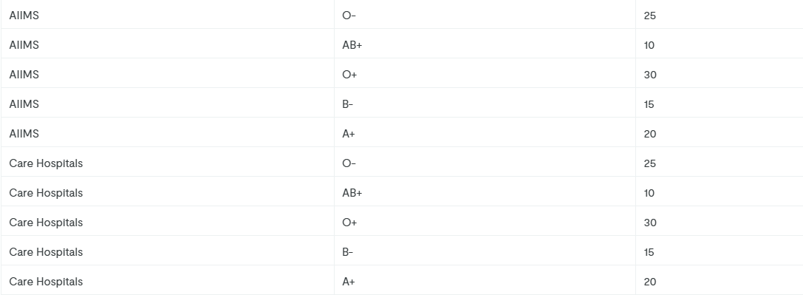

#Donors with Hospitals in the same City (INNER JOIN on Location)

SELECT d.DonorName, d.BloodGroup, h.HospitalName, h.Location

FROM Donor d

INNER JOIN Hospital h ON d.Address LIKE CONCAT('%', h.Location, '%');

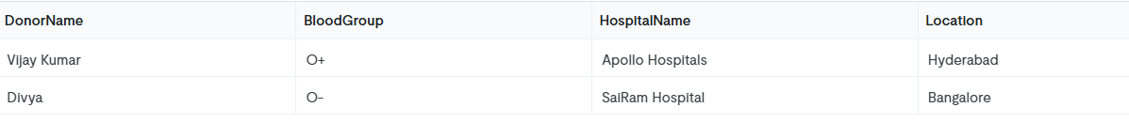

#Acceptor and Donor Matching by BloodGroup (INNER JOIN)

use Blood_Banking_System;

SELECT a.AcceptorName, a.BloodGroup, d.DonorName, d.DonationDate

FROM Acceptor a

INNER JOIN Donor d ON a.BloodGroup = d.BloodGroup;

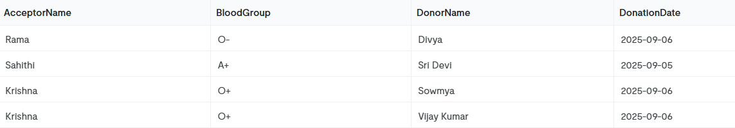

Aggregate Functions

Count total donors

use Blood_Banking_System;

SELECT COUNT(*) AS TotalDonors

FROM Donor;

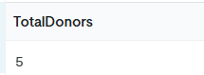

### Find average age of donors

SELECT AVG(Age) AS AverageDonorAge

FROM Donor;

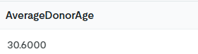

Count donors by blood group

SELECT BloodGroup, COUNT(*) AS DonorCount

FROM Donor

GROUP BY BloodGroup;

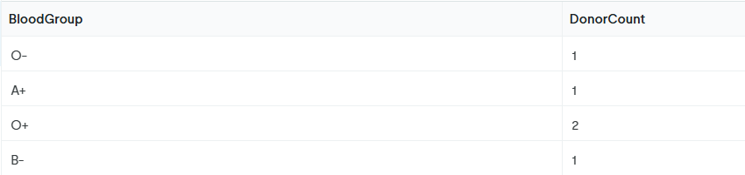

Maximum units available in BloodBank

SELECT MAX(UnitsQuantity) AS MaxUnits

FROM BloodBank;

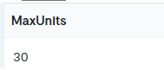

Total units of blood available by group

SELECT BloodGroup, SUM(UnitsQuantity) AS TotalUnits

FROM BloodBank

GROUP BY BloodGroup;

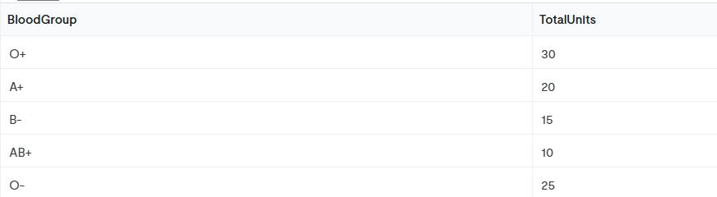

Average age of emergency donors

SELECT AVG(Age) AS AvgEmergencyDonorAge

FROM Emergency;

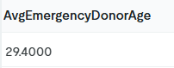

Number of acceptors per city

SELECT Address, COUNT(*) AS AcceptorCount

FROM Acceptor

GROUP BY Address;

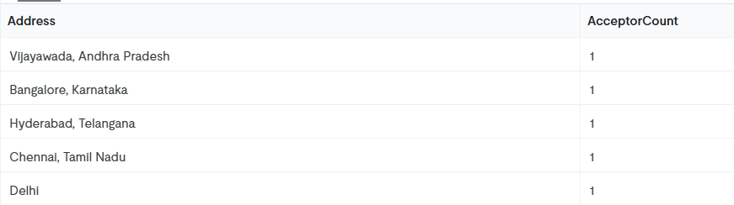

Donors with minimum and maximum age

SELECT MIN(Age) AS YoungestDonor, MAX(Age) AS OldestDonor

FROM Donor;

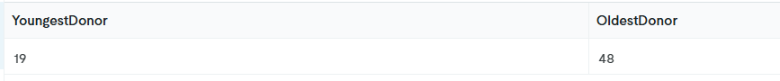

Hospitals count by location

SELECT Location, COUNT(*) AS HospitalCount

FROM Hospital

GROUP BY Location;

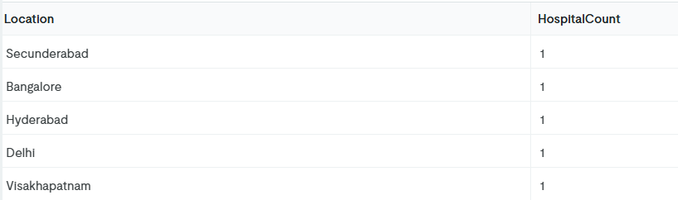

Acceptor blood units required (sum by blood group)

SELECT BloodGroup, SUM(UnitsQuntity) AS TotalUnitsRequired

FROM Acceptor

GROUP BY BloodGroup

HAVING SUM(UnitsQuntity) > 1;

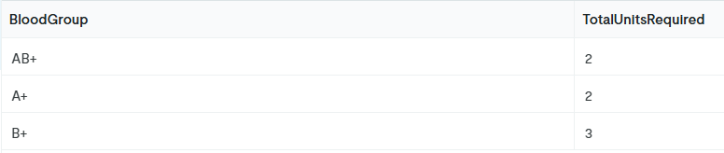

Sub Queries

Donors who donated most recently (based on DonationDate)

use Blood_Banking_System;

SELECT DonorName, DonationDate

FROM Donor

WHERE DonationDate = (SELECT MAX(DonationDate) FROM Donor);

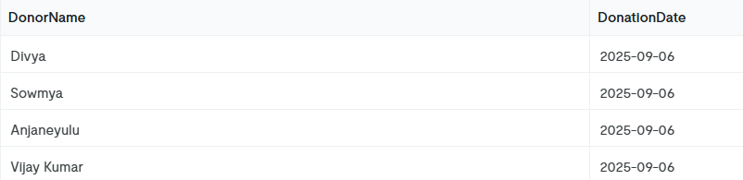

Donors with blood groups required by acceptors

SELECT DonorName, BloodGroup

FROM Donor

WHERE BloodGroup IN (SELECT BloodGroup FROM Acceptor);

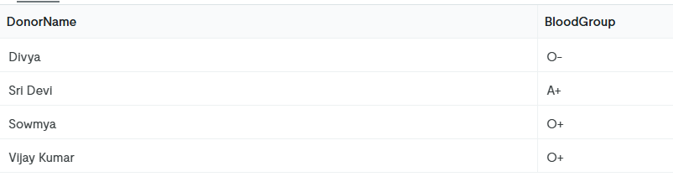

Hospitals in the same city where donors live

SELECT HospitalName, Location

FROM Hospital

WHERE Location IN (SELECT Address FROM Donor);

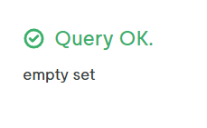

Blood groups available in BloodBank but not yet requested by acceptors

SELECT BloodGroup

FROM BloodBank

WHERE BloodGroup NOT IN (SELECT BloodGroup FROM Acceptor);

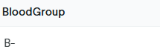

Emergency donors matching the youngest donor’s age

SELECT DonarName, Age

FROM Emergency

WHERE Age = (SELECT MIN(Age) FROM Donor);

